Light intensity can be input by any of the three units listed below: intensity in Watts, intensity in einsteins/L-s and dimensionless efficiency. The model should be able to exchange among the three methods.
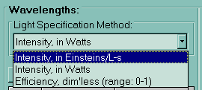
Figure 1 Light Intensity Input Methods

The relationship among these three expressions is given in the following equations.

Exchange between UV intensity in eins/L.s and watts:
Exchange between UV intensity in watts and UV lamp efficiency:
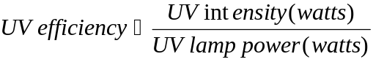
Exchange between UV intensity in eins/L.s and UV lamp efficiency:

The meaning of the numbers:

0 - Light intensity in (eins/L*s)
1 - Light intensity in (watts)
2 – UV efficeincy

Equation for changing from 0→1:
UV(watts) = UV(eins /L*s) *0.12 * Volume(L)/Wavelength(nm)
Equation for changing from 0→2:
UV efficiency = UV(eins /L*s) *0.12 * Volume(L)/[Wavelength(nm)*Lamp Power(watts)]
Equation for changing from 1→0:
UV(eins/L*s) = UV(watts)* Wavelength(nm)/[0.12*Volume(L)]
Equation for changing from 1→2:
UV efficiency = UV(watts)/Lamp Power(watts)
Equation for changing from 2→0:
UV(eins/L*s) = UV efficiency * Lamp Power(watts) * Wavelength(nm) /[0.12*Volume(L)]
Equation for changing from 2→1:
UV (watts) = UV efficiency * Lamp Power(watts)

